10 FREE REGISTRATIONS
for

Charing Cross International Symposium 2022
In person and virtual
26-28 April 2022

The Institute of Vascular Diseases (IVD) is offering five (5) in person free registrations (registration, flights, accommodation, ground transportation) and five (5) virtual free registrations to attend Charing Cross International Symposium 2022, on 26-28 April 2022. For more information, please visit https://www.cxsymposium.com/
To claim free registration, you can be a qualified intern, resident surgeon or qualified physician.
You are kindly requested to send an email to ivd.contactus@gmail.com with the following information: full name, profession, medical facility, email, telephone number, address.
The e-mail should be sent by 18:00 pm, on April 15th, 2022 at the latest.
Registrations will be handled on a first-come first-served basis and successful candidates will be informed via email on 18th of April 2022, by 14:30p.m.
On behalf of IVD,
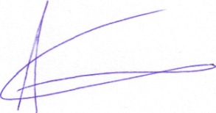
Prof. Athanasios Giannoukas

