20 FREE REGISTRATIONS
for

Charing Cross International Symposium 2021
Digital Edition
19-22 April 2021

The Institute of Vascular Diseases (IVD) is offering 20 free registrations to Charing Cross International Symposium 2021, Digital Edition, 19-22 April 2021. For more information, please visit https://www.cxsymposium.com/cx2021/
To claim free registration, you can be a qualified intern, resident surgeon or qualified physician.
You are kindly requested to send an email to ivd.contactus@gmail.com with the following information: full name, profession, medical facility, email, telephone number, address.
The e-mail should be sent by 12:00a.m, on March 29th, 2021 at the latest.
Registrations will be handled on a first-come first-served basis and successful candidates will be informed via email on 30th of March 2021, by 14:30p.m.
On behalf of IVD,
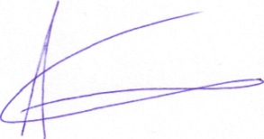
Prof. Athanasios Giannoukas

