2 FREE REGISTRATIONS
for

10th edition of the International Congress:
Aortic Surgery | Peripheral & Venous “How To Do It”,
Milan, Italy, December 15-17, 2022
In person

The Institute of Vascular Diseases (IVD) is offering two (2) in person free registrations (registration, flights, accommodation) to attend 10th edition of the International Congress: Aortic Surgery | Peripheral & Venous “How To Do It”, Milan, Italy, December 15-17, 2022. For more information, please visit https://www.aorticsurgery.it/
To claim free registration, you can be a qualified intern, resident surgeon or qualified physician.
You are kindly requested to send an email to ivd.contactus@gmail.com with the following information: full name, profession, medical facility, email, telephone number, address.
The e-mail should be sent by 17.00 pm, on December 2nd, 2022 at the latest.
Registrations will be handled on a first-come first-served basis and successful candidates will be informed via email on December 3rd, 2022, by 14:30p.m.
On behalf of IVD,
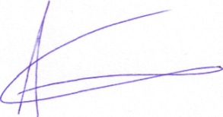
Prof. Athanasios Giannoukas

